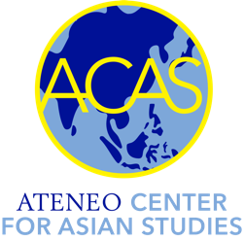
ATENEO DE MANILA UNIVERSITY
Philippines

Study Grant for Bahasa Indonesia

The Ateneo Center for Asian Studies (ACAS) offers a Study Grant to students admitted to its Bahasa Indonesia language courses. Grantees receive a 50 percent discount on the course fee. Miscellaneous fees such as costs of books or printouts of instructional materials are not included.

The responsibilities of a grantee and the conditions of the Study Grant are as follows:

1) Regular attendance of classes and active participation in class activities. These will be
monitored through recordings of class sessions or other means. Up to three unexcused
absences will be allowed; otherwise the student will be removed from the class.

2) Observance of class policies that involve, among others, intellectual honesty, privacy of
data shared and collected during class, and copyright rules applying to instructional
materials.

3) A student who has been removed from class due to unexcused absences and poor
performance (such as: failure to take quizzes or take part in similar activities) will be
a) disqualified from similar ACAS programs in the future;
b) charged the whole amount of the course fee (PHP 5,000).

To apply for the Study Grant, please submit a letter of application indicating
1) the relevance of the language course to your professional and personal interests, and
2) acceptance of the terms and conditions of the grant.
Please email the letter on or before the close of the registration period to:

Violet Valdez, PhD
Executive Director
Ateneo Center for Asian Studies
acas.soss@ateneo.edu

